
Pax Place - Holiday Let

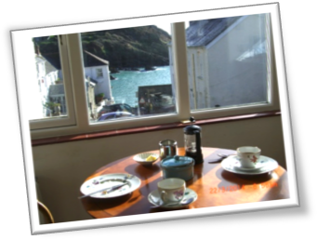
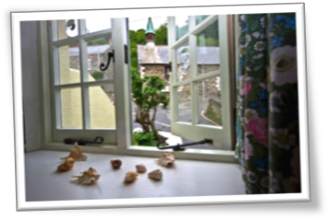
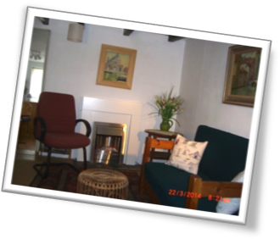
Pax Place, Portloe, Cornwall, TR2 5QX

2015 - Particulars, Terms and Conditions

Pax Place is a good base whether you wish to walk, recharge your batteries, chill out or explore Cornwall

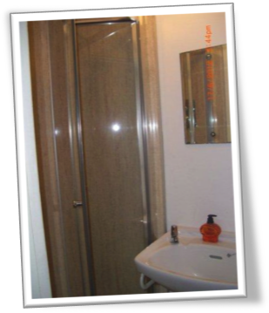
Pax Place…
Enter Pax Place through dark blue front door opposite Church and telephone box in the centre of Portloe into sitting room with kitchen beyond and upstairs bedroom with 4’6” double bed with no end, shower, WC and hand basin.

Arrival/Departure: Friday.

Linen and towel provided. No beach towels.

Equipment: Refrigerator with small freezer compartment, microwave/oven, electric hob and kettle, toaster, TV with DVD, radio, broadband, books, cards and board games. Telephone for incoming calls only. Telephone box across the road. Heating by electric thermostatically controlled wall panel heaters.

Parking is often possible between Pax Place and the harbour. Otherwise there is a car park about 5 minutes walk away.

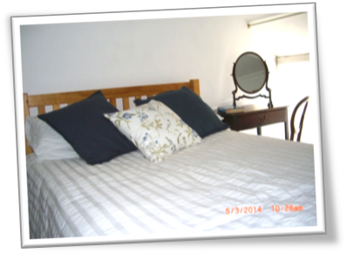
Directions…
By Car: From Tregony follow signs to Veryan/St Mawes until petrol station and shop where you fork left. Continue until sign to Portloe to left. Keep on road down hill and enter village and continue past car park to Church and phone box on your right.

By Train and Bus: To Truro and bus to Portloe

Pax Place with the dark blue front door is opposite the Church.
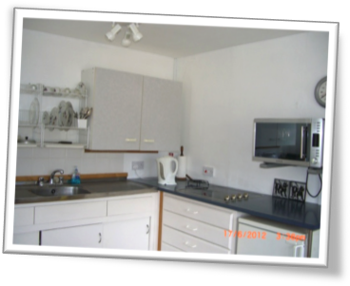
Local Area…
Swim in Portloe harbour or at Carne/Pendower beach.

Walk the costal path passing the door and other footpaths

Eat out in Portloe at the Lugger Hotel or nearby at the Nare Hotel.

Buy newspapers and shop at Texaco garage (passed on your way to Portloe) as well as Veryan and Tregony.

Bus stop outside the Church. Change at Texaco garage for bus to St Mawes and ferry to Falmouth or explore Truro and further afield.

Terms & Conditions…
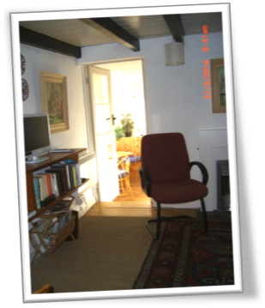
Accommodation for 1 or 2 adults.

Sorry, no pets, children or smoking allowed.

Week commences 4.30pm on the first Friday of your holiday and ends at 10am on the Friday of your departure.

Deposit: £100.00
Payment: Due four weeks before your holiday starts. Non payment of the balance of the rent by the due date shall be construed as a cancellation of the contract. If Pax Place cannot be re-let you will be responsible for the full cost of the holiday. If Pax Place unavailable due to circumstances outside my control the rental money received will be returned.

Key: Arrangements will be posted on completion of payment for holiday let with inventory.

Please check when you arrive and let me know of any missing items or breakages. Complaints cannot be accepted after the tenancy has ended.

The hirer is responsible for any loss or damage to the property (reasonable wear and tear excluded), for taking good care of Pax Place and leaving it in a clean and tidy condition. Should it be found that an excessive amount of cleaning is required a charge will be made.

Electricity is included in the rent except in low season.

Limited Broadband access is available for general internet browsing and emails.

All information is given in good faith and no responsibility taken for any errors or omissions.

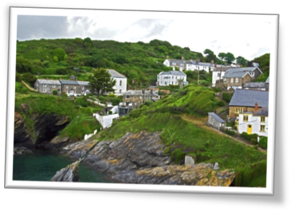

Availability…
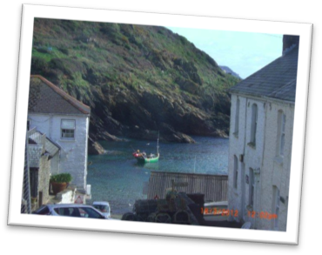
Contact Details…
Dates | Price for 7 nights (£)
3rd January to 4th April |  | £ 334.00
4th April to 16th May |  | £ 434.00
16th May to 6th June |  | £ 525.00
6th June to 15th August |  | £ 434.00
15th August to 29th August |  | £ 525.00
29th August to 19th Dec |  | £ 434.00
19th Dec to 9th Jan 2015 |  | £ 525.00
For further information about Pax Place or to confirm availability
(Please remember to state the planned date of your visit and duration):

Email: jenpax1@yahoo.co.uk Telephone: 01386 840272
Booking Form for 2015…

Please complete the following details and send with cheque to: -
Mrs A. J. Kissel, Garden Cottage, Chipping Campden, GL55 6AL



Name(1): ................................................................................................................................
Name(2) .................................................................................................................................
Address:.................................................................................................................................
…………………………..............................................................................................................
..................................................................... Postcode: ........................................................
Telephone Number: …………………………….. Mobile Number: ................................................
Email: ......................................................................................... Nationality..........................
Broadband access: Yes …… No ……
Dates From : Friday ........................................... To : Friday .................................................. 2015
Deposit: £100.00
Signed (1): .................................................................Date: ………………………………………… 2015
Signed (2): …………………………………………….......... Date: ……………………………..……..….. 2015

